AI Use Declaration Form
Course: Introduction to Artificial Intelligence
Lab Title: Lab 3
Student Name: ____________KUKUWA AMOAH_______________________________________
Student ID: __34122028____________________________________________________
GitHub Repository Link: https://github.com/Kukuwa-amoah/lab-3/blob/main/kukuwamoah_lab3.ipynb
Date Submitted: ___28/07/26_______________________________________________

1. AI Use Summary
Question | Student Response
Did you use any AI tool for this lab? | Yes
Estimated percentage of the work influenced by AI | %25
Did you attach evidence of AI use where applicable? | yes

2. Details of AI Use
Complete the table below for each AI tool used. Add more rows where necessary.
Name of AI Tool Used | Purpose for Using the Tool | Prompt or Instruction Given to the Tool | Part(s) of the Work Influenced by the Tool | How I Verified, Edited, or Improved the AI Output
chatgpt | To understand concepts |  | Debugging,understanding concepts and errors too | I used it to understand the work

3. Attachment of AI Output Evidence
Where required, attach evidence of AI use. Tick all that apply. Add more rows where necessary.
Evidence Type | Attached? (Yes, No, N/A) | File Name
AI-generated draft | N/A
Prompt history | N/A
Screenshot of AI interaction | YES | Images below, after declaration form
Exported AI conversation | N/A
AI-generated code snippet | YES | Images below, after declaration form
Revised version showing student input | N/A

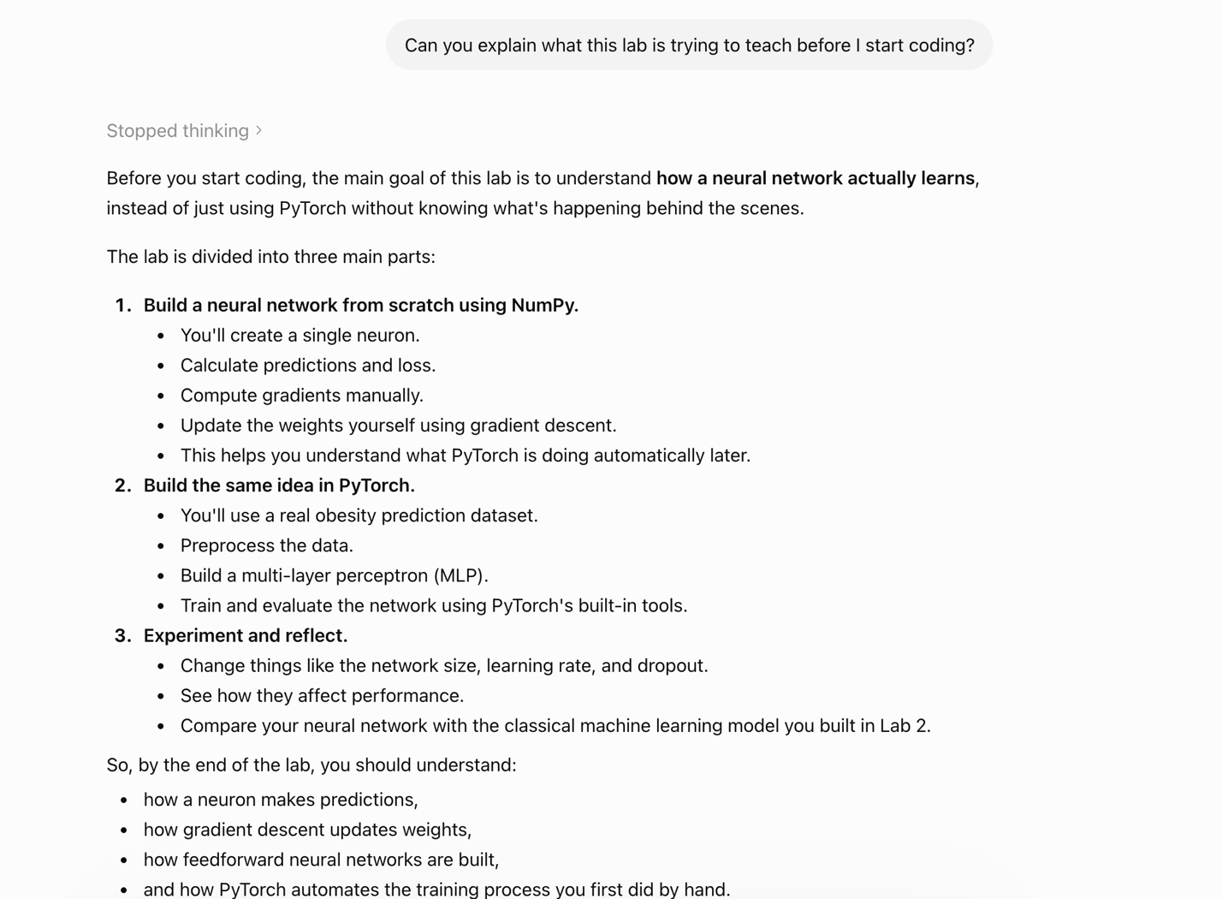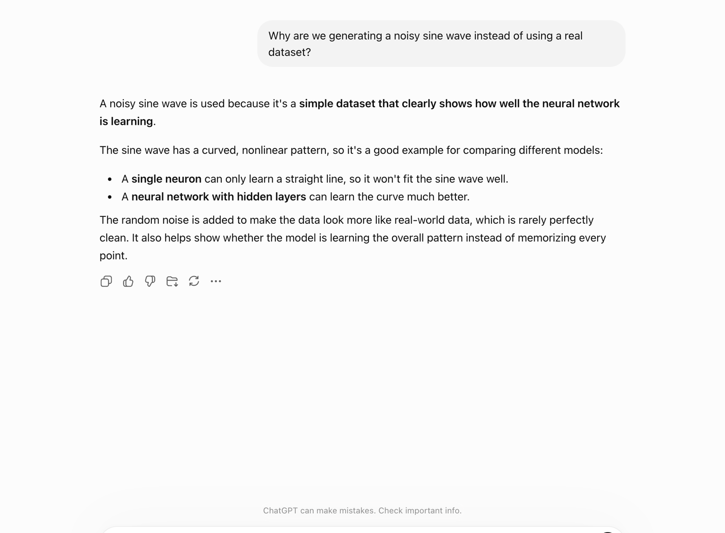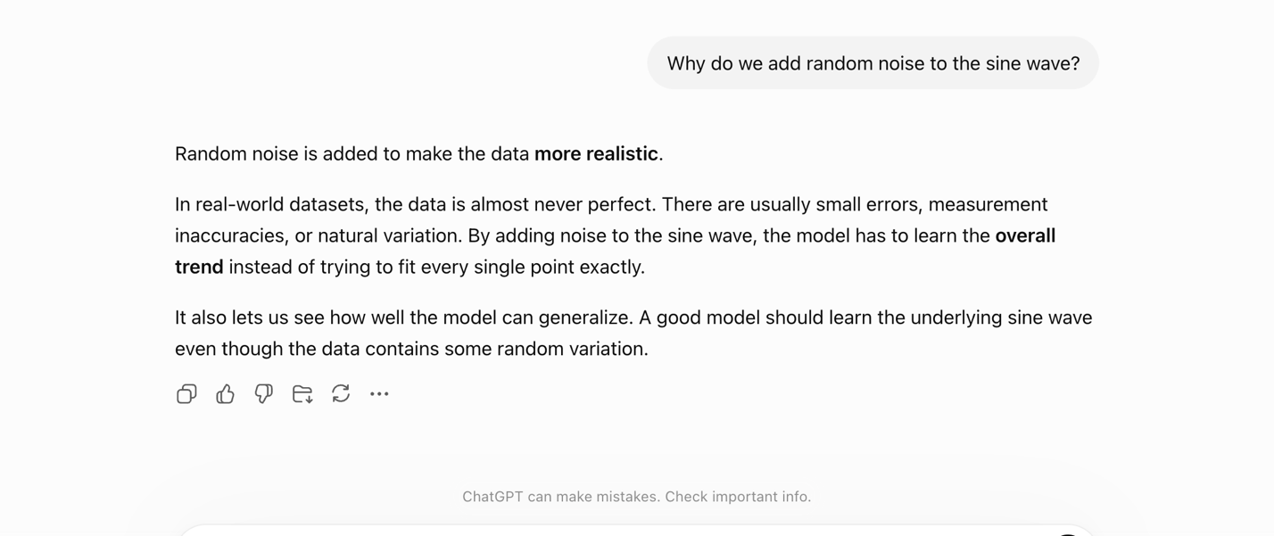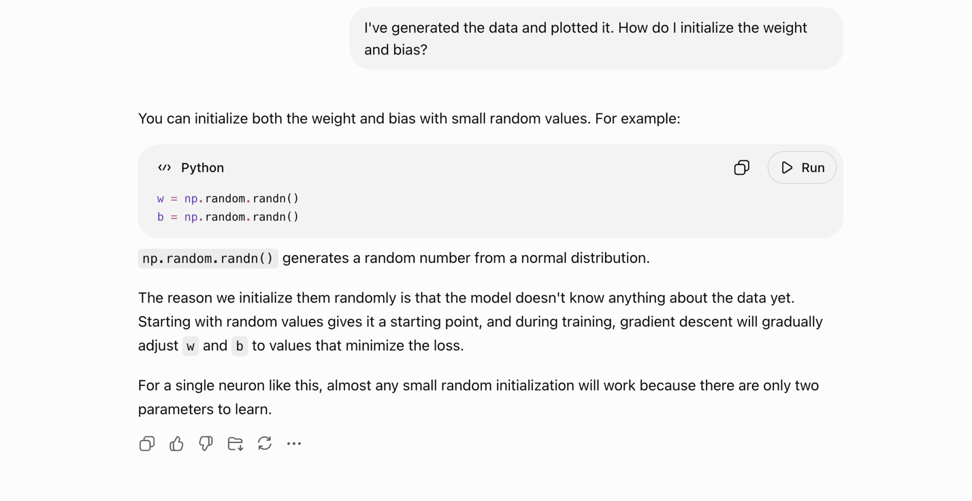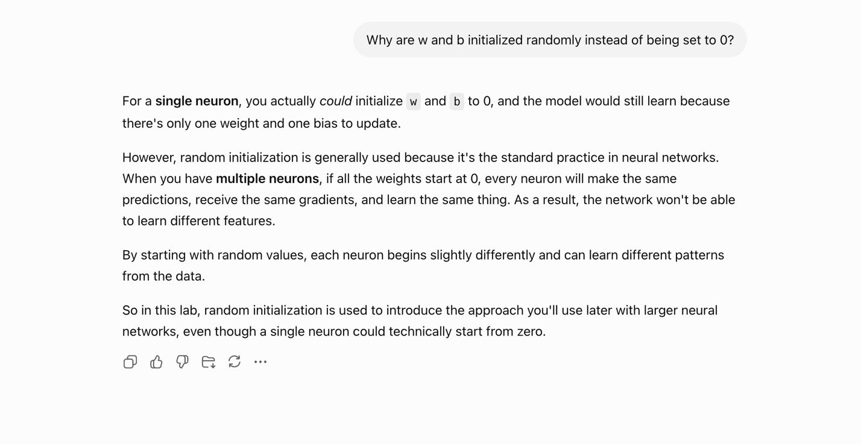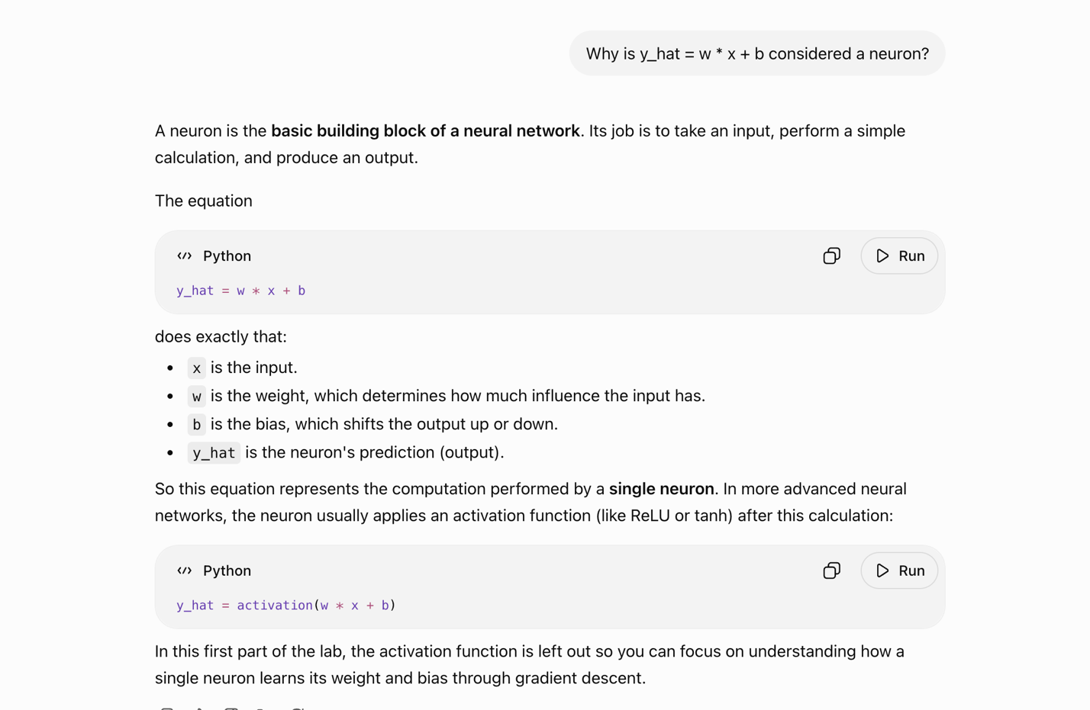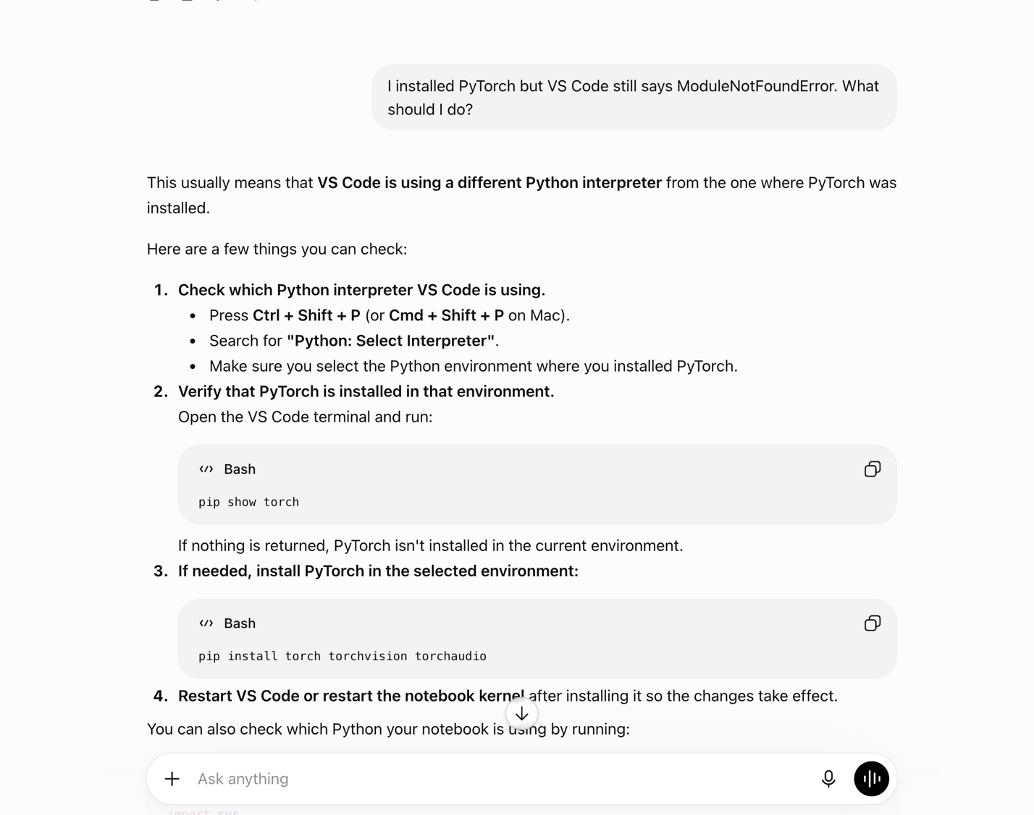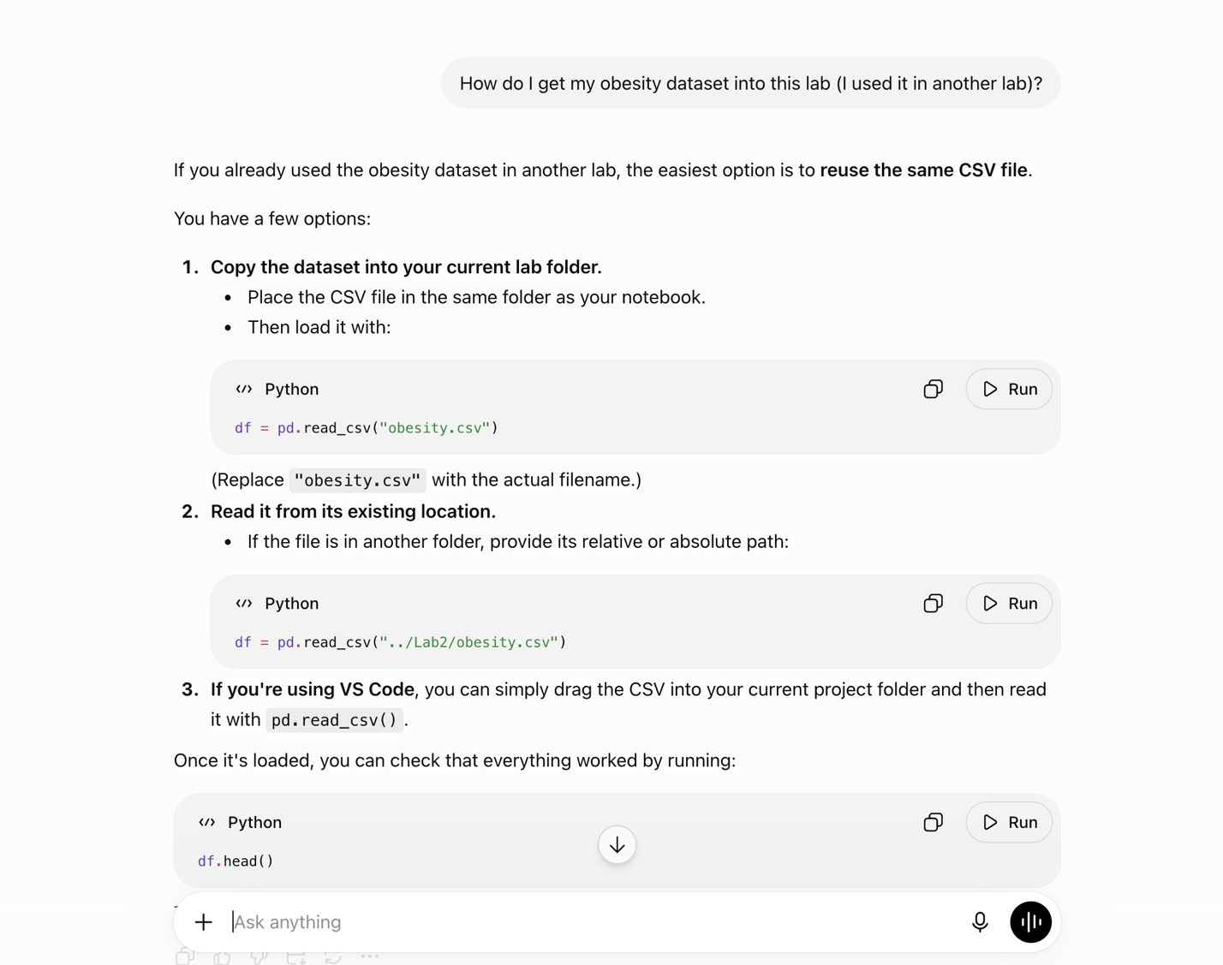

4. Student Declaration
I declare that:
Declaration Statement | Response (Yes/No)
The submitted work is my own work. | YES
Any use of AI tools has been clearly declared in this form. | YES
The prompts, instructions, and AI-generated outputs have been disclosed where applicable. | YES
I reviewed, tested, edited, and improved any AI-generated content before submission. | YES
My AI usage does not exceed 25% of the entire work. | YES
I understand that undeclared or excessive AI use may be treated as academic misconduct. | YES

Student Signature: ____K.A_______________________________________
Date: _____28/06/26______________________________________

